Miss Jackson Name:
Biology Period:

Understanding Photosynthesis

1. Name the following parts of the chloroplast:

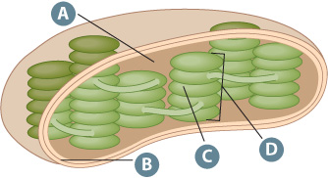

A: ___________________

B: ___________________

C: ___________________

2. Label the following diagram
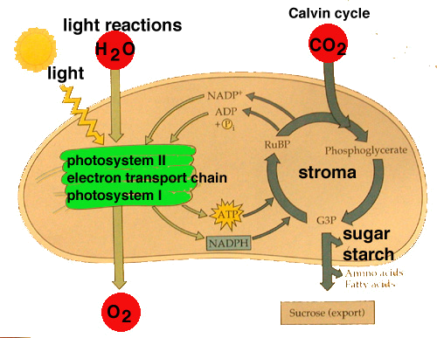
3. Fill in the following chart
 | Light Reactions | Dark Reactions ( )
Where

Reactants

Products

